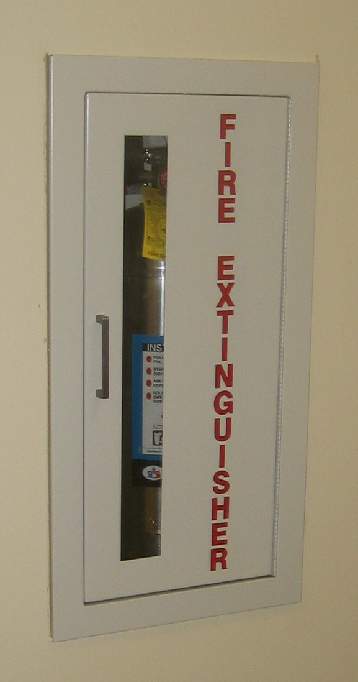
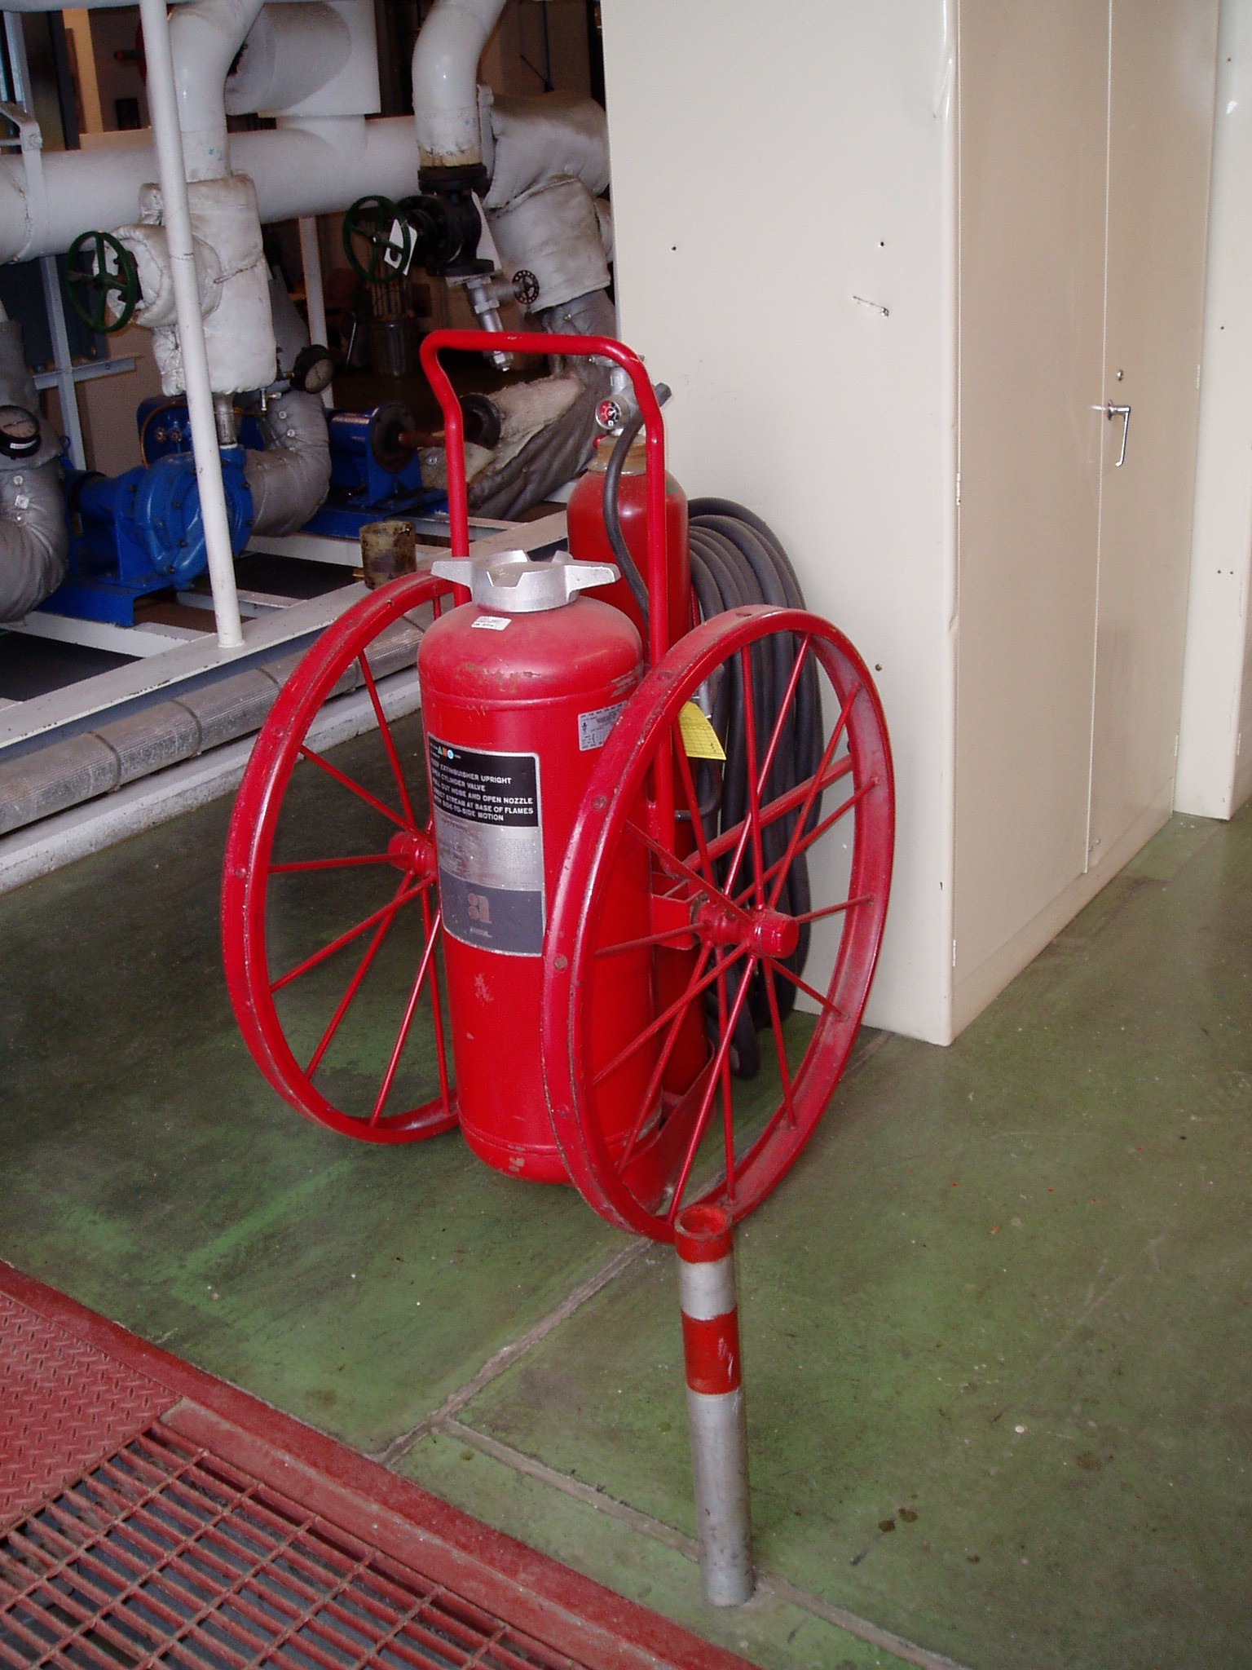
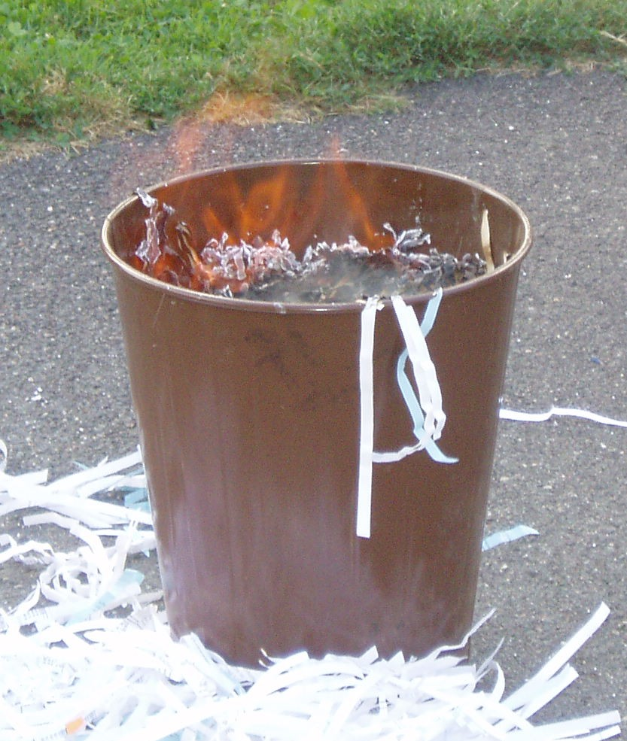
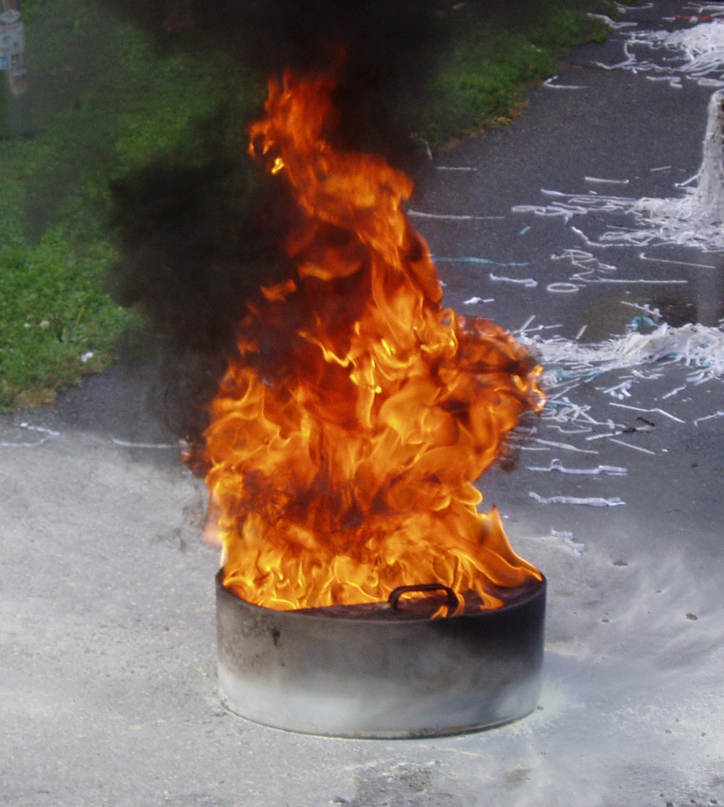
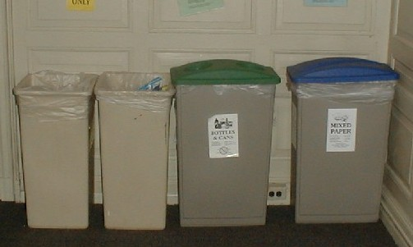
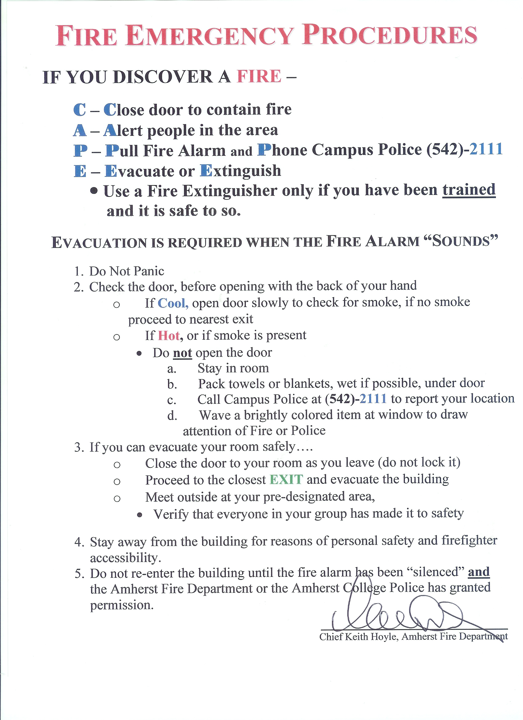
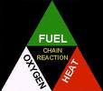
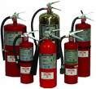
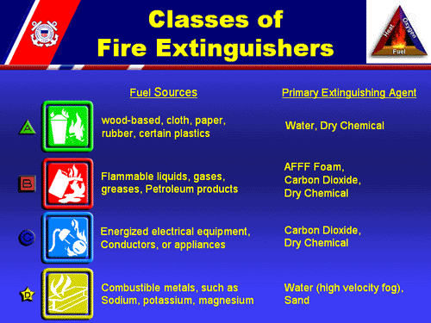
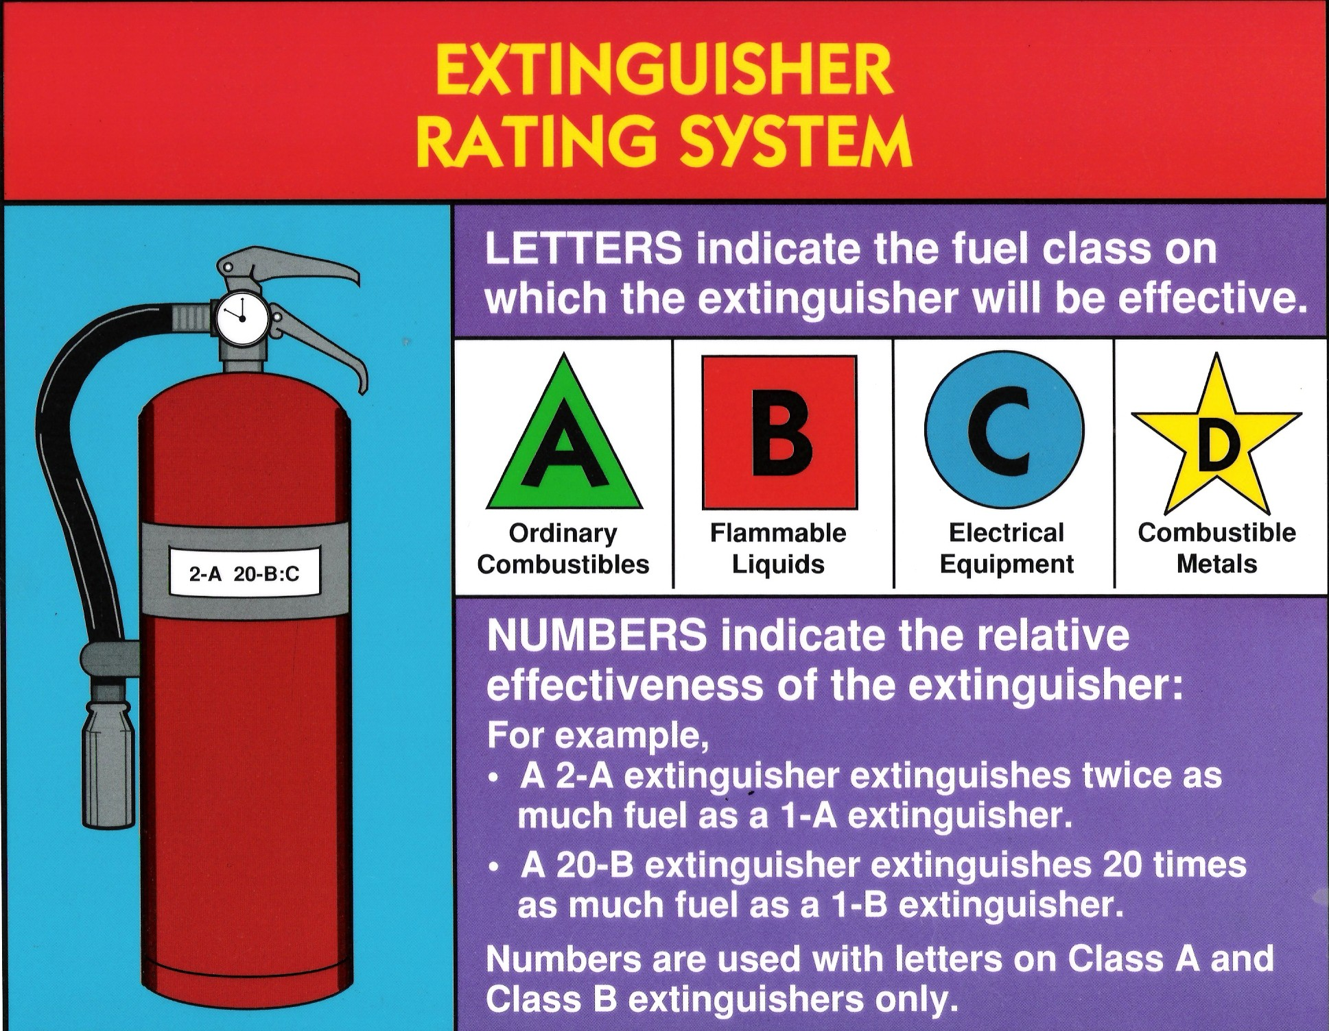
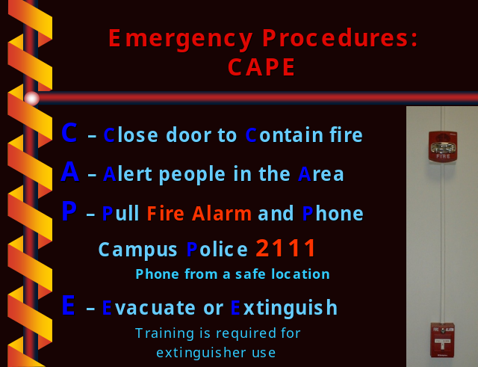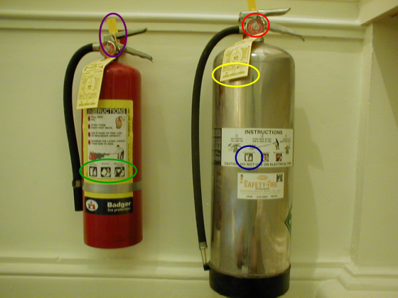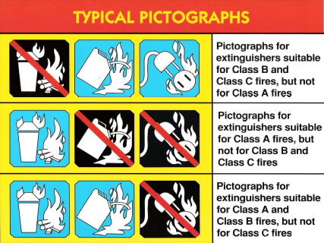Fire Extinguisher Training
Fire and/or Smoke Condition
- If a fire is discovered, follow the Amherst College Emergency Procedures, regardless of whether or not you can control the incident
- Evacuate / Extinguishment
- Never use a fire extinguisher unless you have been trained and it is safe to do so.
- Lack of training, or the use of the wrong extinguisher could result in fire spread or serious injury.

Fire Tetrahedron
- All 4 must be present to have a fire
- Remove any one of the 4…Fire goes out
Fire Classifications
- A – Ash producing materials
- B – Liquids found in a Barrel
- C – Circuit or Current
- D – Dangerous Metals
- K – Kitchen Cooking Equipment
Fire Extinguishers
Campus Locations
- P/W (Pressurized Water)
- 30’ for ~ 1 minute
- Residence Halls
- ABC (Dry Chemical)
- 15’ for ~ 30 seconds
- Kitchen/Laboratory/Vehicle
- CO2 (Carbon Dioxide)
- 5’ for ~ 15 seconds
- Electrical/Lab/Mechanical
- K (Acetic Acid/Vinegar)
- 10’ for ~ 30 seconds
- Schwems and Valentine
- Metl-X
- Laboratory
Fire Extinguisher Inspections
- Type and Pressure Gauge
Pull the pin – Test the fire extinguisher to make sure it works
Aim the extinguisher at the base of the fire
Squeeze the handle to activate the fire extinguisher
Sweep across the base of the fire from side to side until agent blankets or cools the fire.

