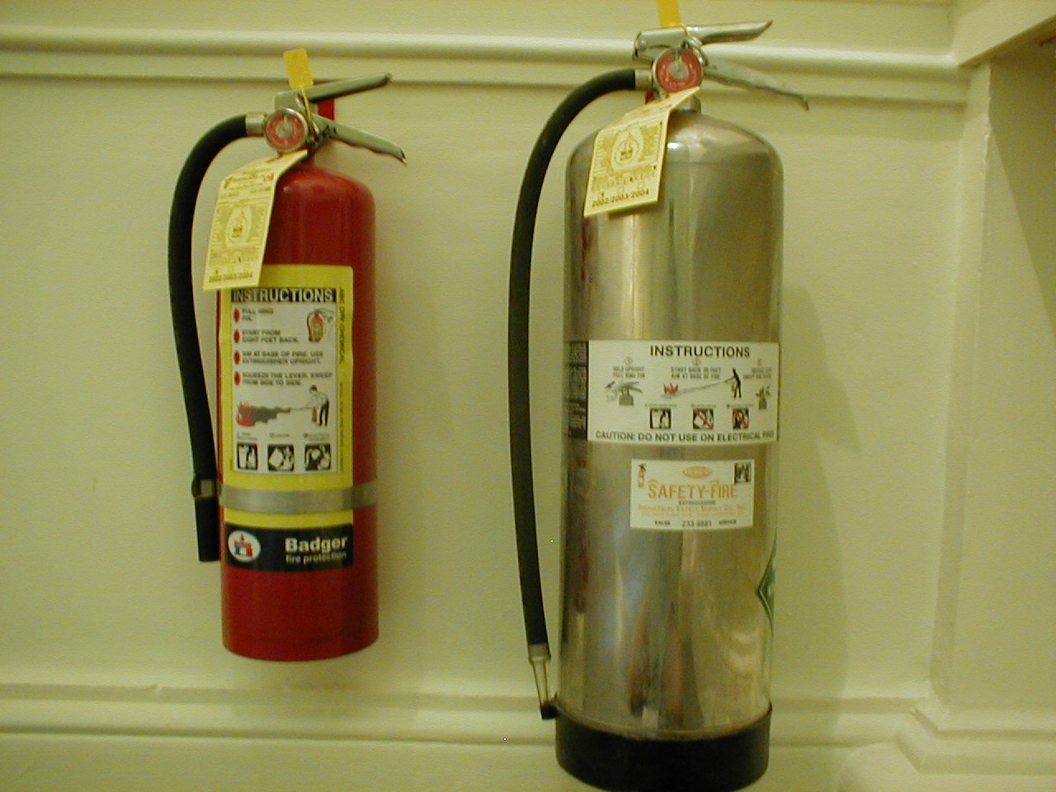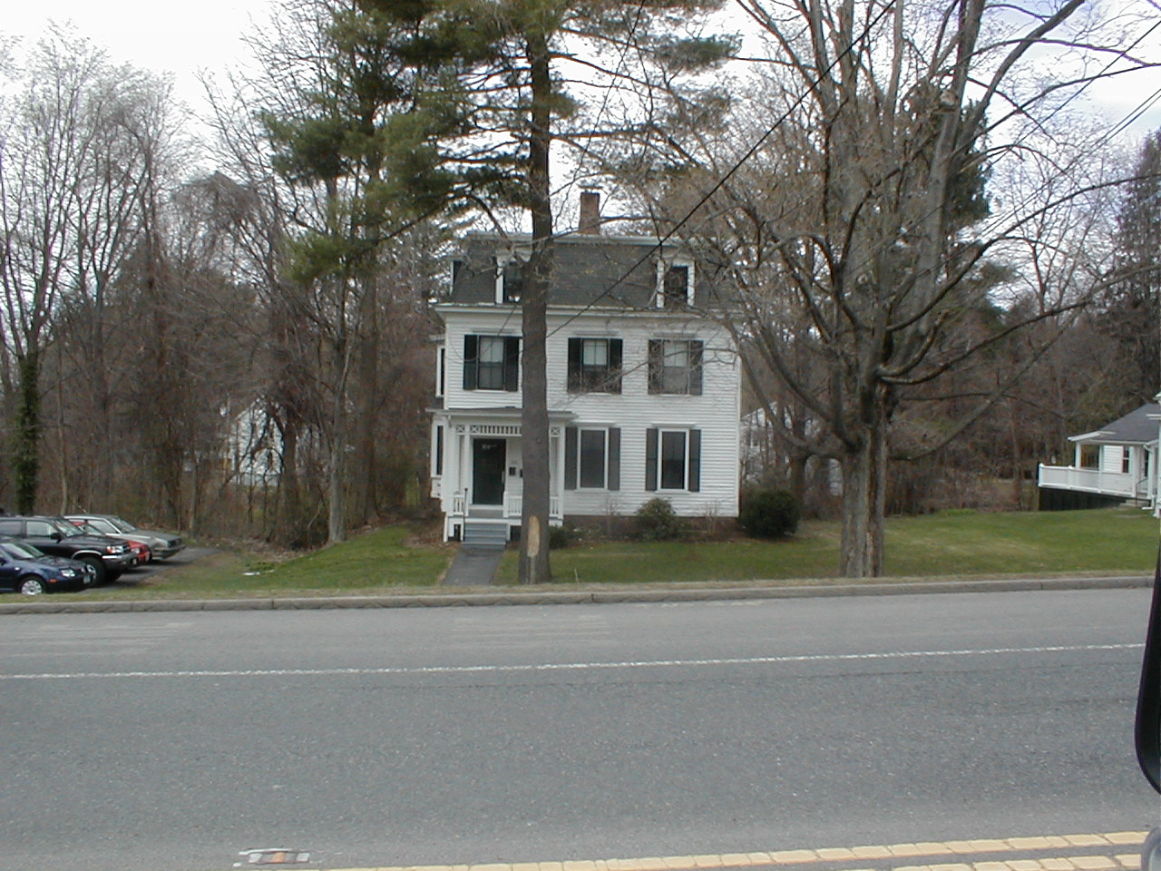Chapman, Davis, Hamilton and Moore Dormitory all have something in common…

With in the last 5 years they have all experienced a fire that was successfully extinguished with a fully charged, ready to use
Fire Extinguisher
Do NOT permit Fire Extinguisher Tampering
Report improper use and discharged fire extinguishers to the

Campus Police 542 - 2291
The next Fire could be here!

