Math 29 Midterm 2 Score Summary

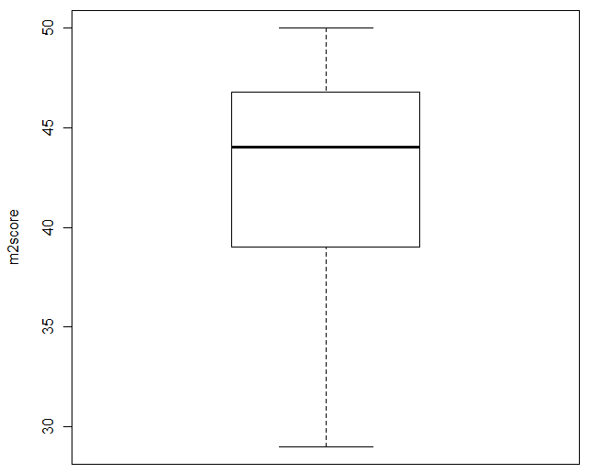
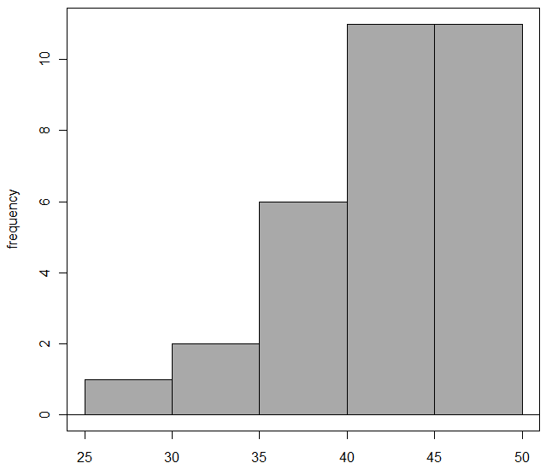

mean sd 0% 25% 50% 75% 100% n
42.56452 5.40947 29 39 44 46.75 50 31

