Neuroscience 26 Exam 1 Spring, 2011
This is a closed-book, closed-note, 2-hour exam that is to be taken in Merrill 3. Write your answers legibly in the exam book provided. On questions including a choice, answer only the requested number of items. Good luck!

1. [3 points each x 4 = 12 points] Define or describe any 4 of the following 5 items in a phrase or a single sentence:
a. horseradish peroxidase
b. cell birthday
c. myelin
d. filopodia
e. excitatory postsynaptic potential

2. (10 points). Answer either (A) or (B).

(A) In a couple of sentences, describe the pattern of proliferation of nerve cells during vertebrate development: where does it occur, and over what time in the life of the organism does it take place?
- OR –
(B) Describe the pattern of migration of nerve cells during vertebrate development: in which direction of neurons migrate? At what time in a cell’s development does migration take place?

3. [8 points each x 2 = 16 points] Comment critically in a sentence or two, saying what if anything is correct and what is incorrect, about any 2 of the following 3 statements:

(1) At an excitatory synapse, the neurotransmitter depolarizes the postsynaptic dendrite, causing a nerve impulse to be initiated in the dendrite.
(2) consider a synapse whose reversal potential is equal to a neurons resting membrane potential. When the synpase is active, it produces no current and no change in the cells membrane potential. Therefore this synapse has no effect on the neuron, just as if the synapse didnt exist.
(3) After the hyperpolarization that occurs after a nerve impulse, the Na⁺/K⁺ pump eventually brings the membrane back to its resting state. [From http://hyperphysics.phy-astr.gsu.edu/hbase/biology/actpot.html ]

4. [18 points] Background: The concentration of chloride (Cl⁻ ) 110 mM in the extracellular fluid around a neuron, and the chloride concentration in the intracellular fluid inside the neuron is 11 mM. Other ions: [Na⁺]o = 140 mM, [Na⁺]i = 12 mM, [K⁺]o = 4 mM, [K⁺]i = 150 mM. The resting potential of this cell is -70 mV.

Questions: (a) What is the equilibrium potential of chloride in this situation?
(b) Suppose a synapse caused an increase in permeability to chloride (and only to chloride) in the membrane of this neuron. (i)Would the postsynaptic potential at this synapse be a depolarization or a hyperpolarization? (ii)Would the synapse be excitatory or inhibitory? Make any reasonable assumptions you may need. Give reasons for your answer.

5. (18 points) On the other side of the page are shown two outputs from the Bezanilla squid axon impulse program. (You were not asked to do these particular simulations, so they wont be familiar.) The first one shows the result of stimulating the axon twice with brief depolarizing pulses, each 0.25 milliseconds long, 10 milliseconds apart. Note that each of the two stimuli gives rise to a full, normal action potential. The second run was made with the depolarizing stimulus left on for the whole time of the trace, i.e. instead of the stimulus lasting 0.25 msec, it lasted 15 msec. This may seem like a much stronger stimulus, since it lasts much longer. Note that this long stimulus does produce a 2nd impulse after about 10 msec, but this second impulse is smaller in amplitude than the first one.

Question: In a few sentences, explain the difference in the 2nd impulses in the two runs, referring to the condition of ion channels in the membrane in the two cases.
(Over)

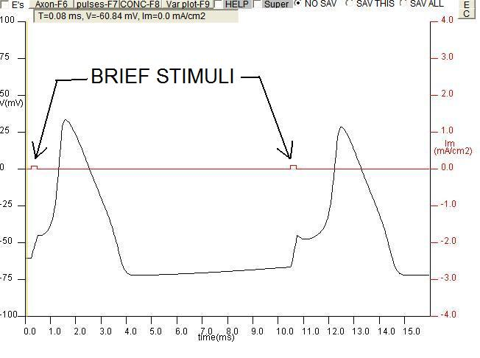
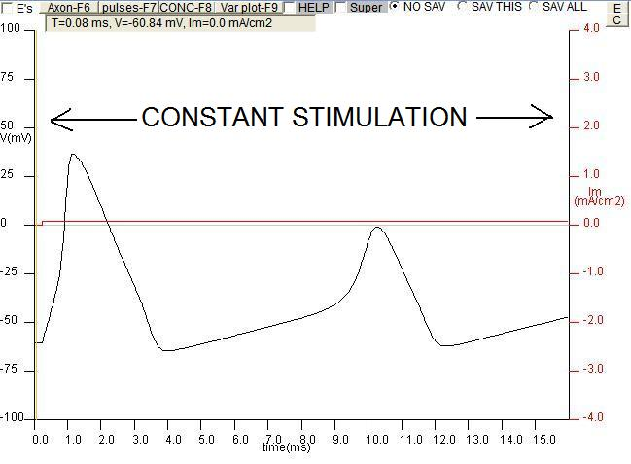

5. [26 points] Answer either (A) or (B) below. Suggested length – 1 page.

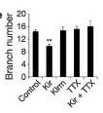
(A) The paper we read by Hua et al. describes experiments on competition between growing axons. As youll recall, they put extra potssium channels in some cells in the developing retina, and measured the terminals of those cells’ axons using fluorescence microscopy to make the individual terminals visible.

(i) Explain the rationale for increasing the number of potassium channels as a way of studying competition. E.g. does potassium itself stimulate or inhibit axon growth, or if not, what is the possible link between potassium channels and axon growth? Use your knowledge of electrical signaling in the part of the course since we read the Hua et al. paper to answer this question.

(ii) At right is one graph showing results from the paper. As you may recall, Kir refers to the cells with the extra K⁺ channels, and Kirm refers to cells with similar extra K⁺ channels but they are non-functional. Explain what these results show.

- OR –
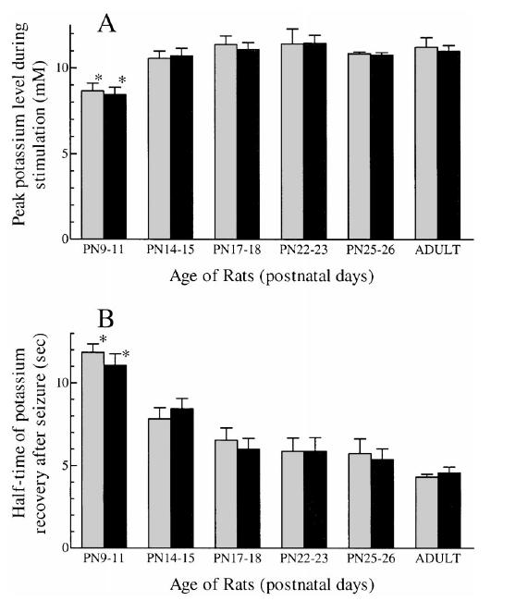
(B) The paper we read by Janet Stringer describes experiments on the role of extracellular potassium concentration changes in accounting for epilepsy in young animals (and hopefully also, humans).

(i) Explain the rationale for testing the link between extracellular K⁺ concentration and hyperexcitability of neurons, i.e. why is it reasonable to test for such a link, based on knowledge of neural excitability.

(ii) At right is a graph of results from the paper. Referring to each of the two graphs separately, explain how each does or does not support the hypothesis that [K⁺]o is responsible for seizures in young animals.

Extra credit question (1 point): What was the surname of the German scientist who derived the Nernst equation for calculating equilibrium potentials?

Possibly useful equations:

I_{na}=g_{Na}(V_{m}-E_{Na}) e^{iπ} + 1 = 0

